**Lab Practical #01:**

Study of basic networking commands and IP configuration.

**Practical Assignment #01:**

1. Perform and explain various networking commands listed below:
   1. ipconfig
   2. ping
   3. getmac
   4. systeminfo
   5. traceroute / tracert
   6. netstat
   7. nslookup
   8. hostname
   9. pathping
   10. arp

## ipconfig

### Description:

* display IP address (IPv4/IPv6)
* To view Wi-Fi or Ethernet connection status
* It helps you check or fix your **internet connection**.
* Shows basic IP address info.

|  |  |  |
| --- | --- | --- |
| No. | Option | Description |
| 1 | Ipconfig | Shows basic network info like Ip address |
| 2 | Ipconfig/all | Shows full details like Ip address, MAC, DNS |
| 3 | Ipconfig/release | Disconnects your Ip address |
| 4 | Ipconfig/renew | Gets a new Ip address from the router |
| 5 | Ipconfig/? | Shows help for all ipconfig commands |

### Implementation:

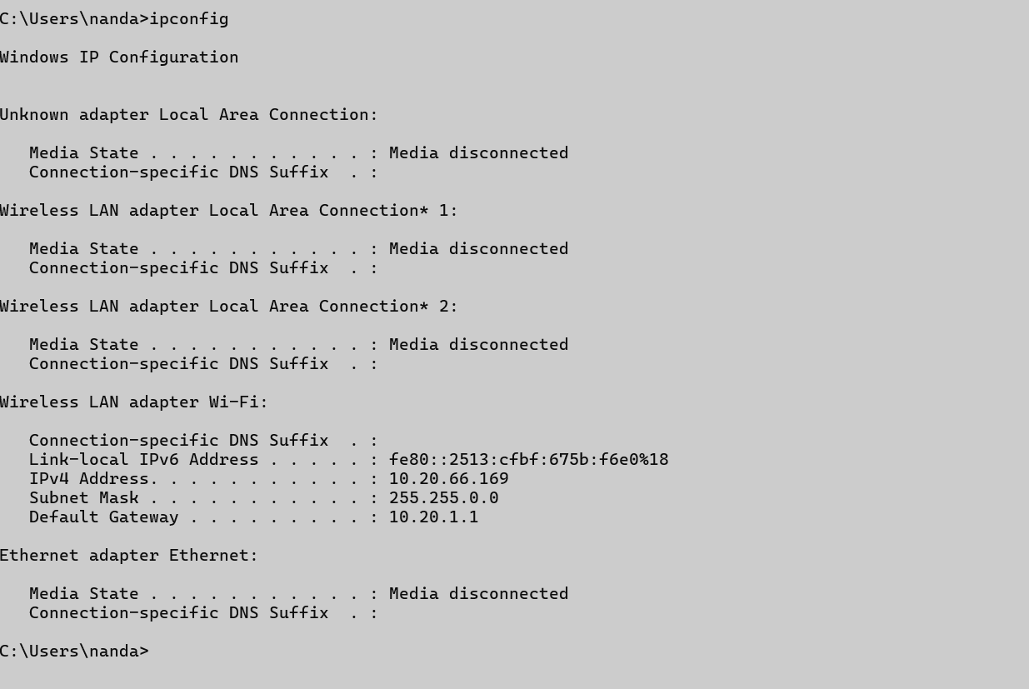Ipconfig:

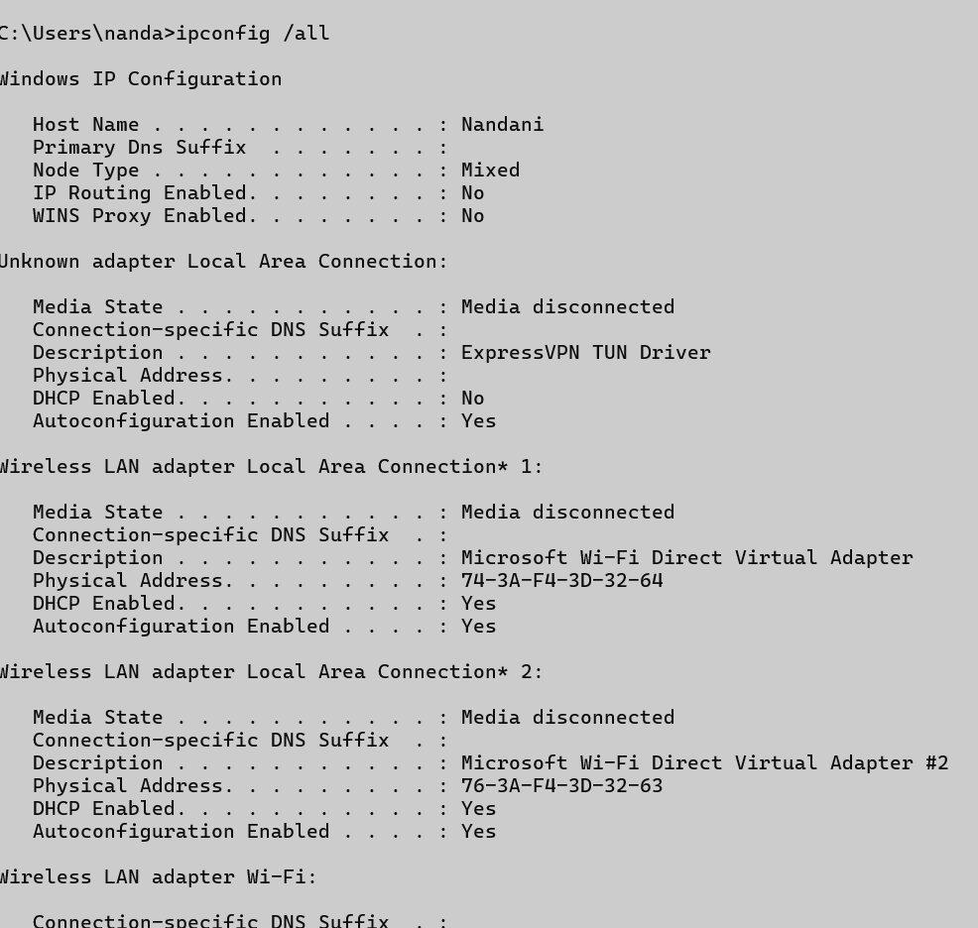Ipconfig/all:

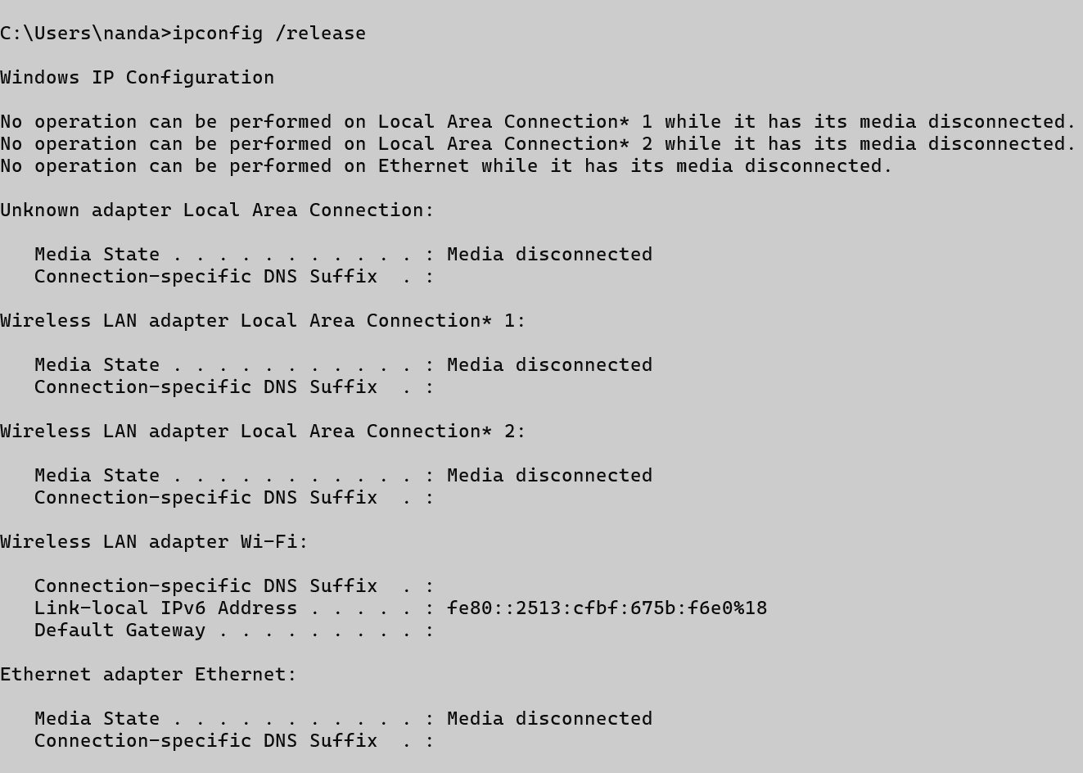Ipconfig/release:

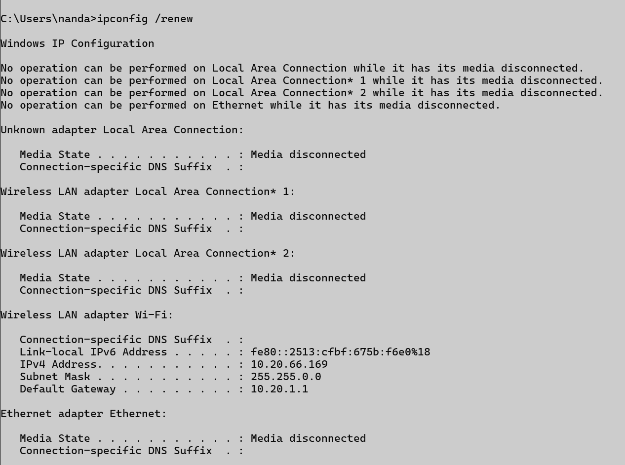Ipconfig/renew:

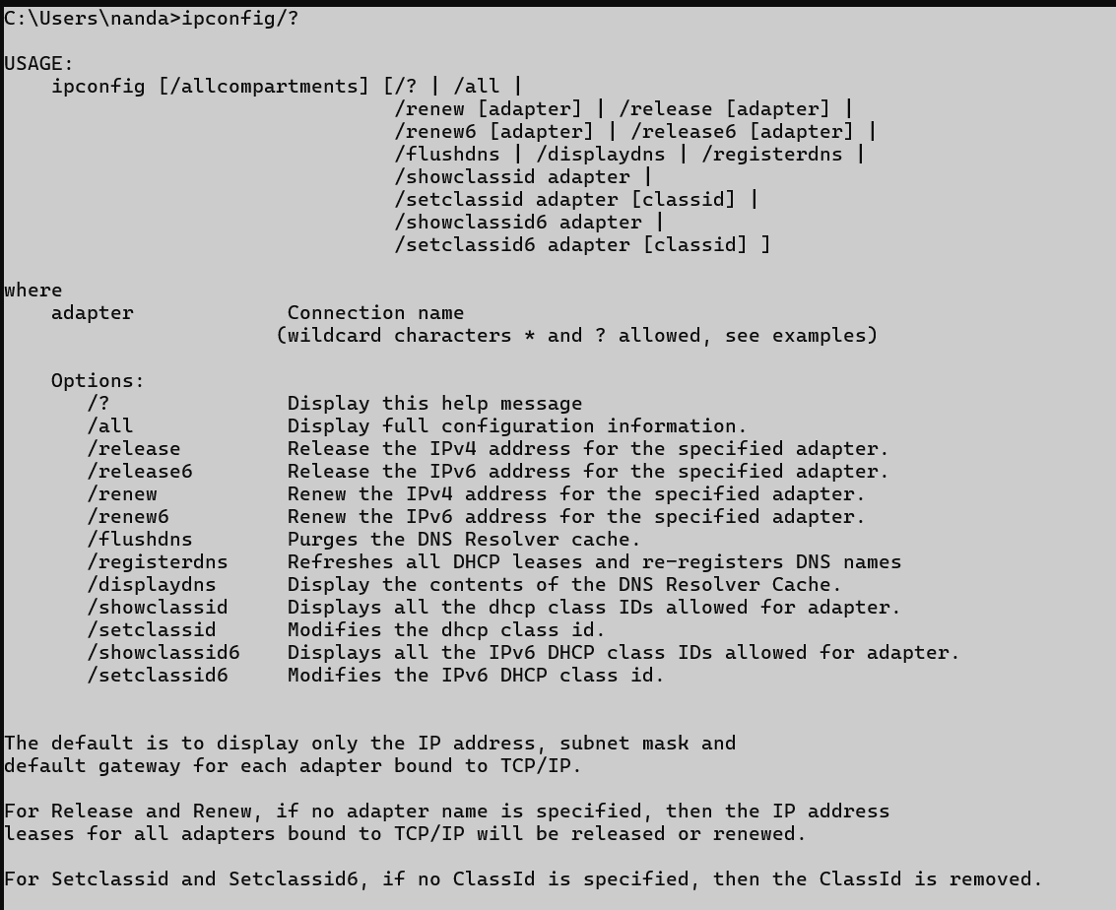Ipconfig/?

## ping

### Description:

* It is used to check if a device is reachable over a network or the internet.
* Check your internet connection.
* Check if internet is working.
* Measure network speed/delay
* Output: response time, TTL (Time to live), packets send and received

|  |  |  |
| --- | --- | --- |
| No. | Option | Description |
| 1 | -a (ping -a google.com ) | Shows the host name from an Ip address. |
| 2 | -t (ping -t google.com ) | Pings continuously until you stop. |
| 3 | -l (ping -l 100 google.com) | Set a custom size of ping packet |
| 4 | -n (ping -n 5 google.com) | Set number of ping to send |
| 5 | ping | Shows help for all ipconfig commands |

### Implementation:

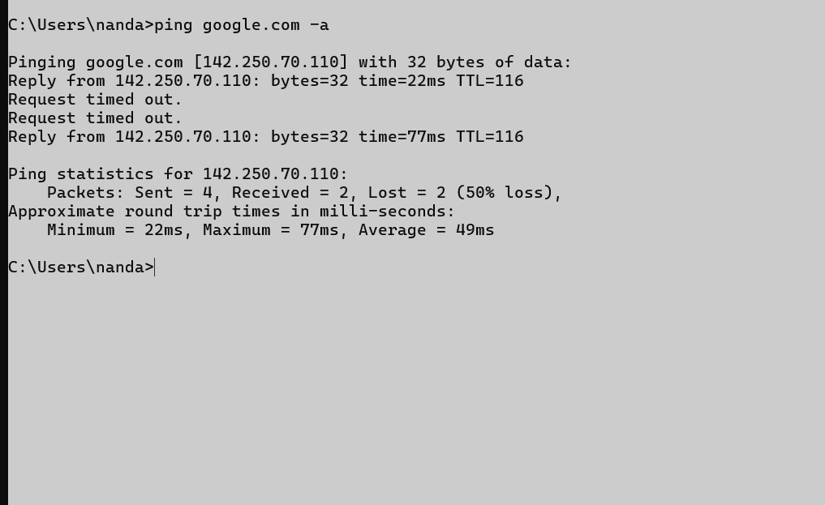ping -a google.com:

Ping -t google.com:

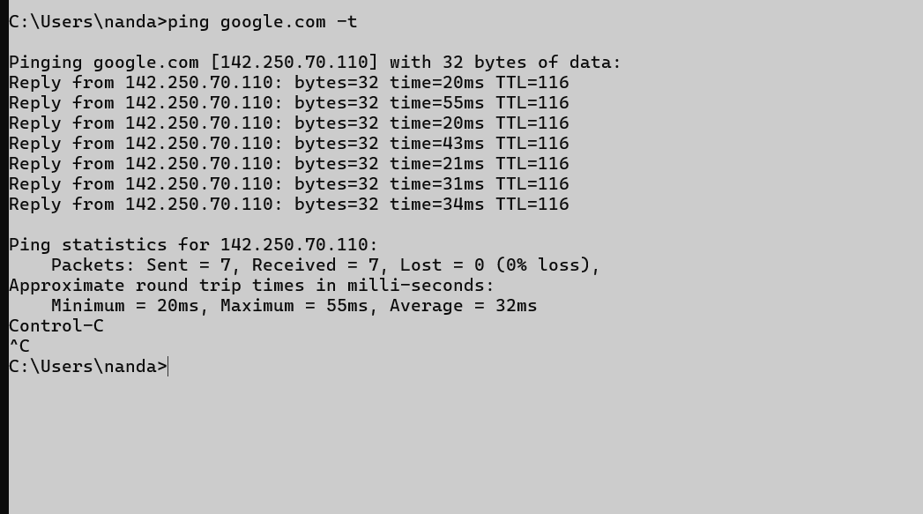

Ping -l 61:

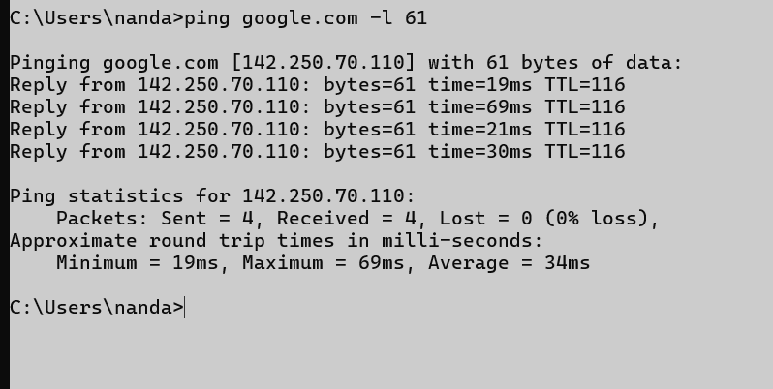

Ping -n 2:

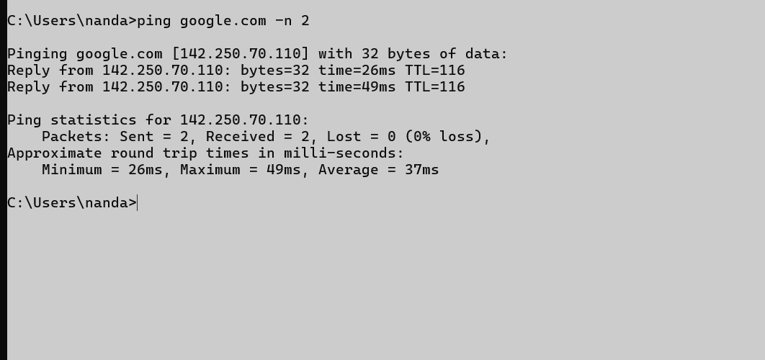

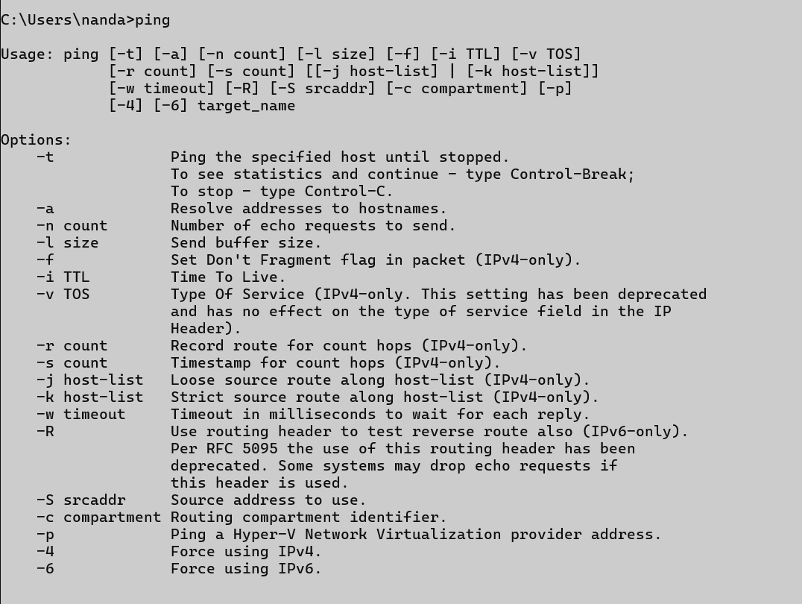Ping:

## Getmac

### Description:

* Shows the MAC address of your computer’s network adapter.
* MAC is unique ID for your computer’s network hardware.
* Find your MAC address and helpful in IT support.

|  |  |  |
| --- | --- | --- |
| No. | Option | Description |
| 1 | Getmac /? | Shows help for all ipconfig commands. |
| 2 | Getmac/ fo csv | Shows output in CSV format |
| 3 | Getmac / NH | Removes the header row. |
| 4 | Getmac/v | Shows detailed info like connection name and status. |

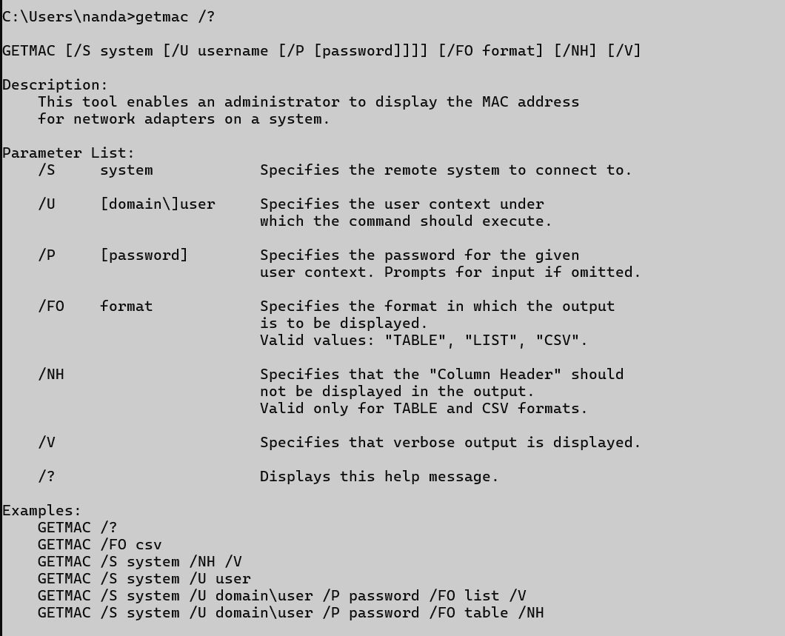Getmac/?:

Getmac / Fo csv:

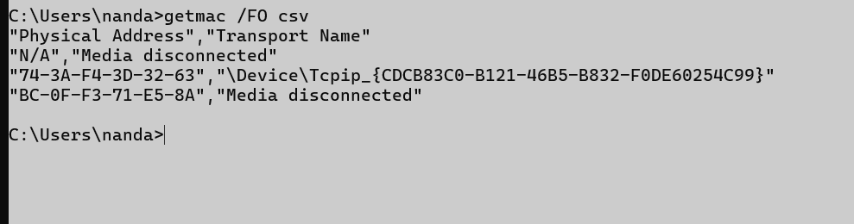

Getmac /NH:

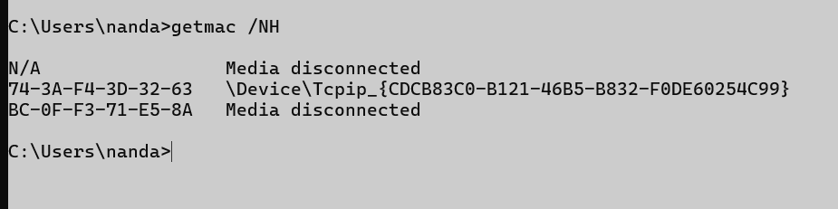

Getmac/v:

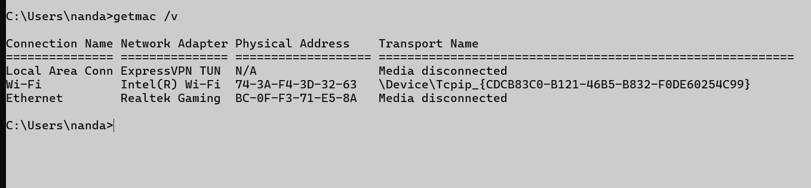

## Systeminfo

### Description:

* Show detailed information about your computer system.
* Give you a full report of your PC’s hardware and software.
* Find the boot time or update history.

|  |  |  |
| --- | --- | --- |
| No. | Option | Description |
| 1 | /s <computer> | Executes the command on a remote computer. Requires appropriate permissions. |
| 2 | /u <domain/use> | Specifies the user context for the remote system. Must be used with /s. |
| 3 | /p <password> | Supplies the password for the user. |
| 4 | /fo table | Formats output as a table. |
| 5. | /nh | Omits column header from output. |

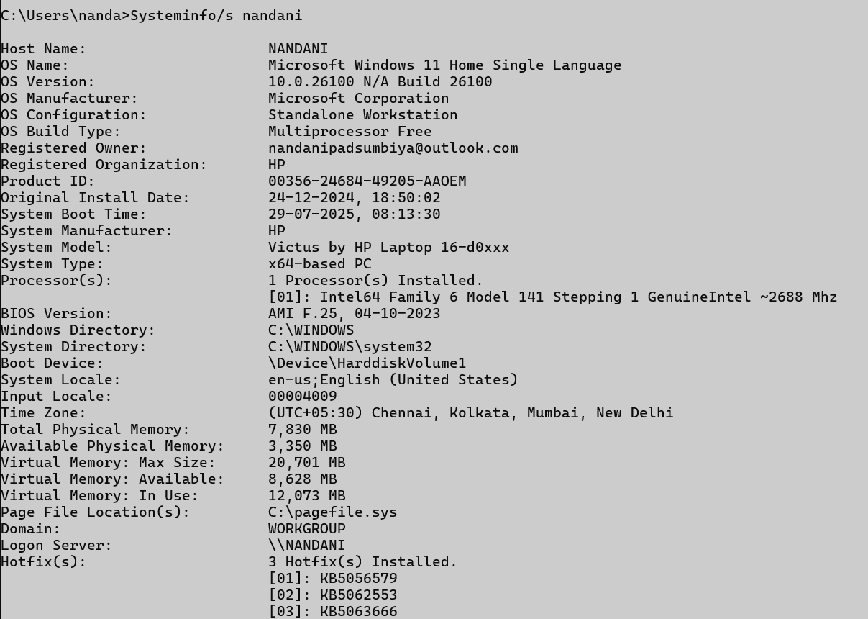Systeminfo/s nandani:

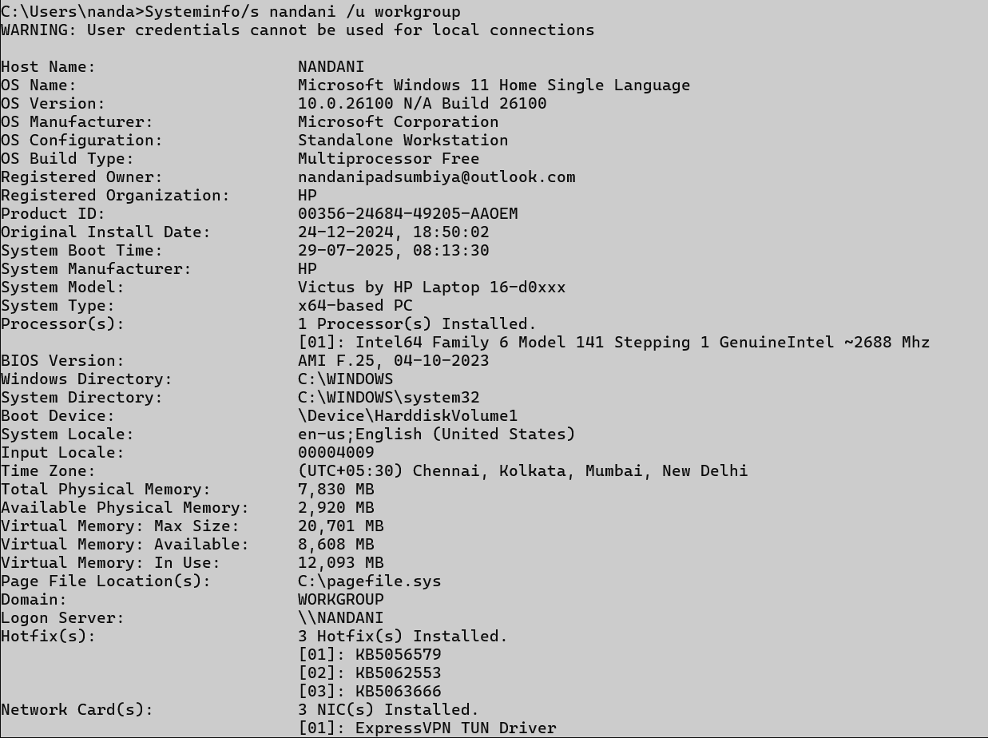Systeminfo/s nandani /u workgroup

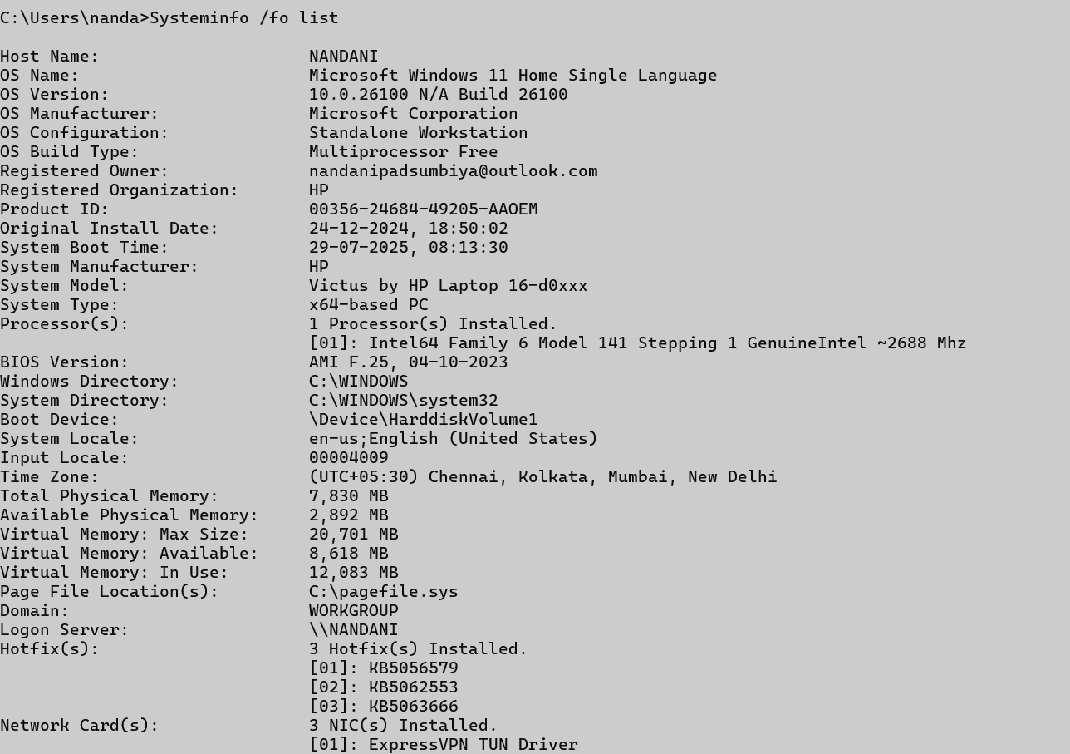Systeminfo / fo list

Systeminfo | findstr “Total Physical “

## Traceroute / tracert

### Description:

* This command shows the full path that your data takes to go from your computer to another website or server on the internet.
* Helps you see how your data travels.
* Helps troubleshoot slow internet or no connection.
* Sends small packets to the destination

|  |  |  |
| --- | --- | --- |
| No. | Option | Description |
| 1 | -d (tracert -d google.com) | Don’t show router names(faster) |
| 2 | -h (tracert -h 10 google.com) | Set how many steps to try |
| 3 | -w (tracert -w 1000 google.com) | Set how long to wait for each hop |
| 4 | -4 (tracert -4 google.com) | IPv4 only (like 192.168.1.1) |
| 5 | -5 (tracert -6 google.com) | IPv6 only (like 2401:4900::1) |

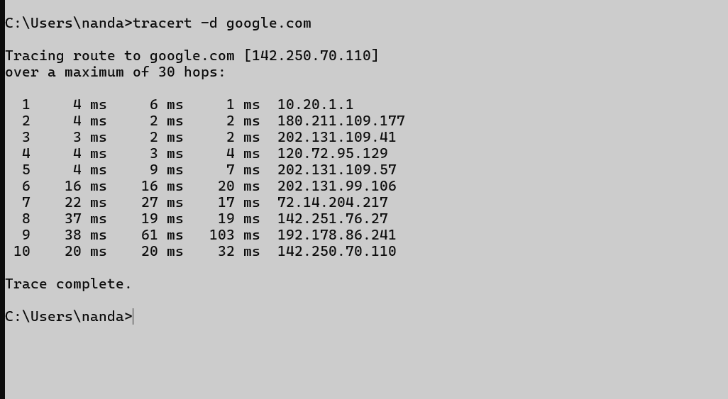Tracert -d google.com:

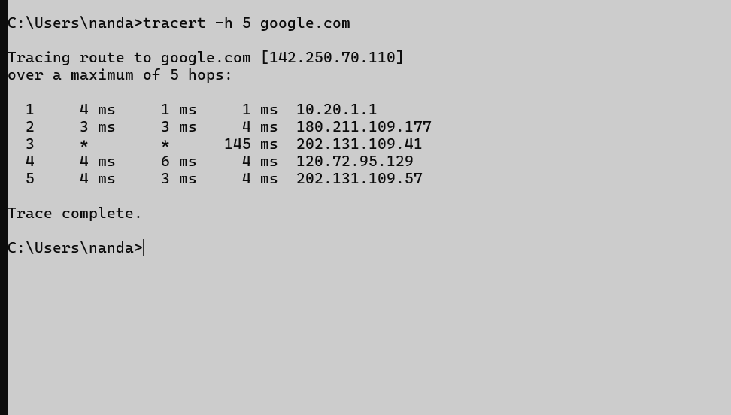Tracert -h 5 google.com:

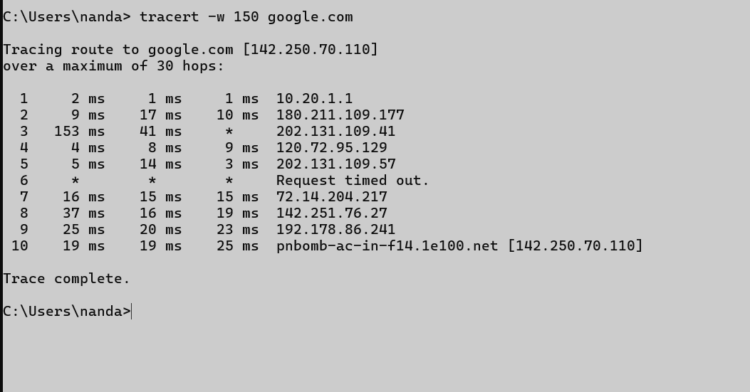Tracert -w 150 google.com:

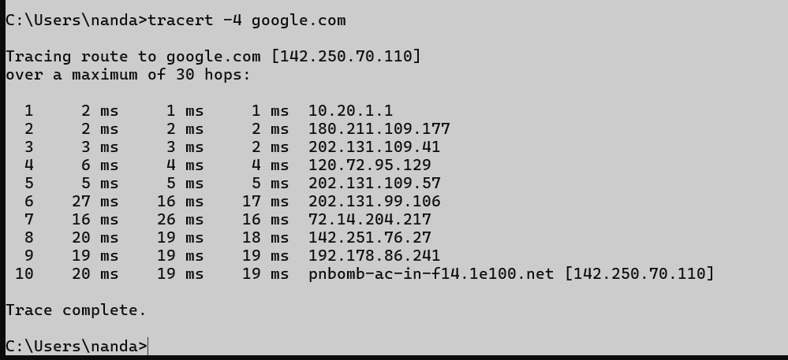Tracert -4 google.com:

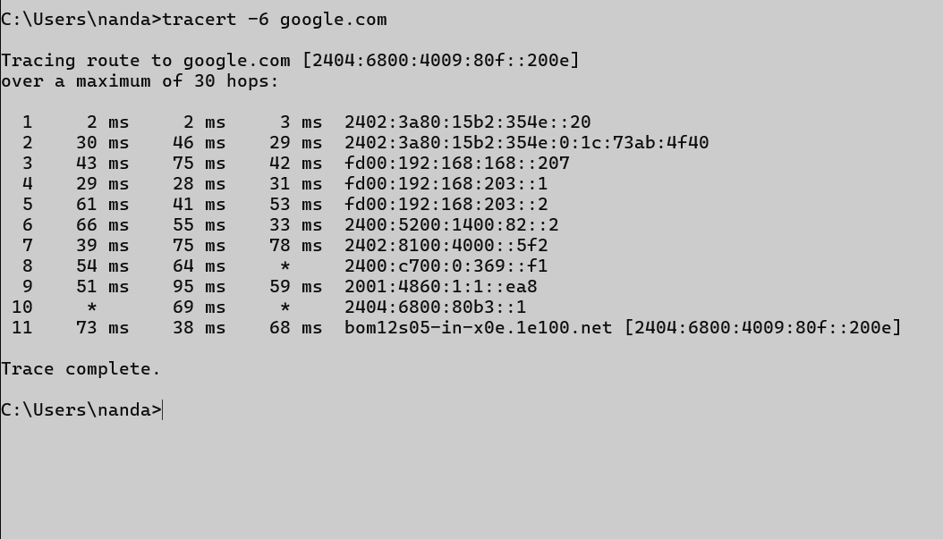Tracert -6 google.com:

## Netstat

### Description:

* Show detailed information about your computer’s network connections.
* To check active internet or network connections.
* To see which programs are using the internet.

|  |  |  |
| --- | --- | --- |
| No. | Option | Description |
| 1 | Netstat/? | Shows detailed info like connection name and status. |
| 2 | Netstat -a | Shows all connections and ports |
| 3 | Netstat -b | Shows the name of the program / app using each connection/port. |
| 4 | Netstat -c | -c is used in Linux, not in windows. |

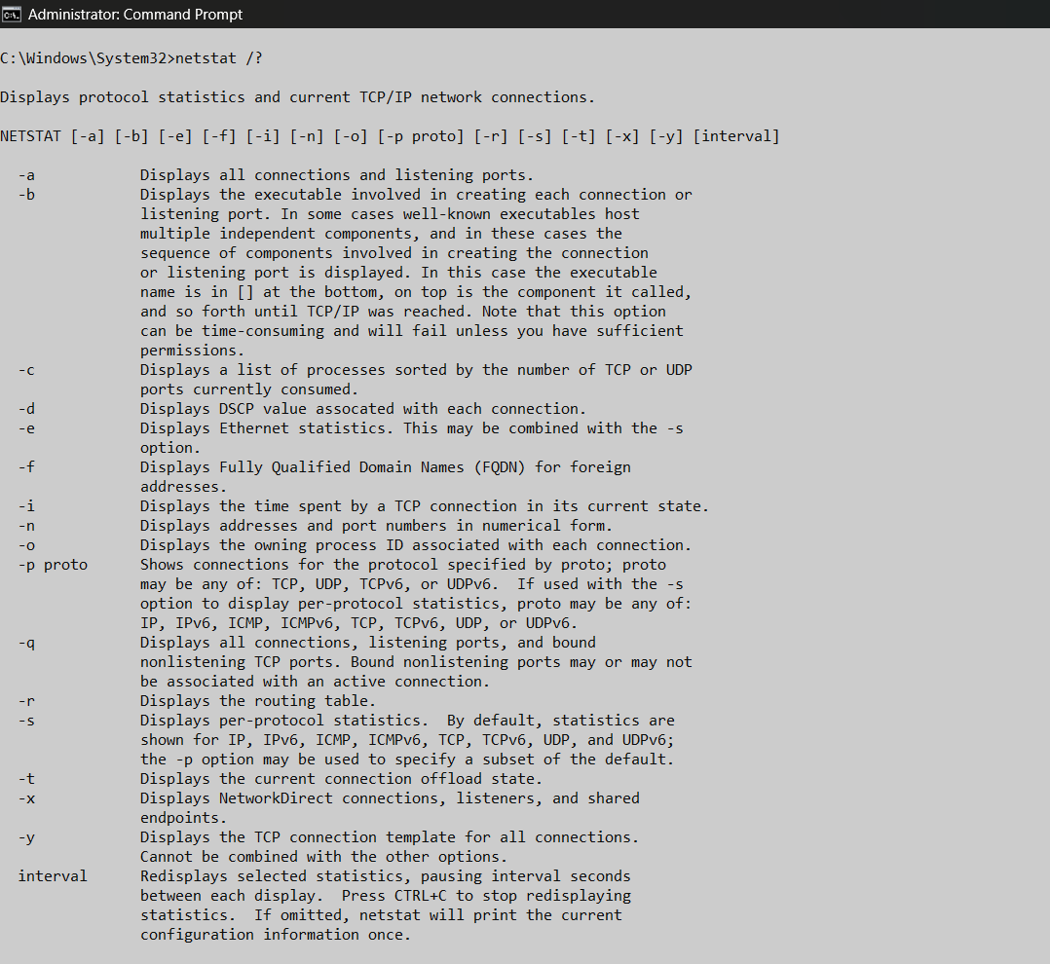Netstat/?:

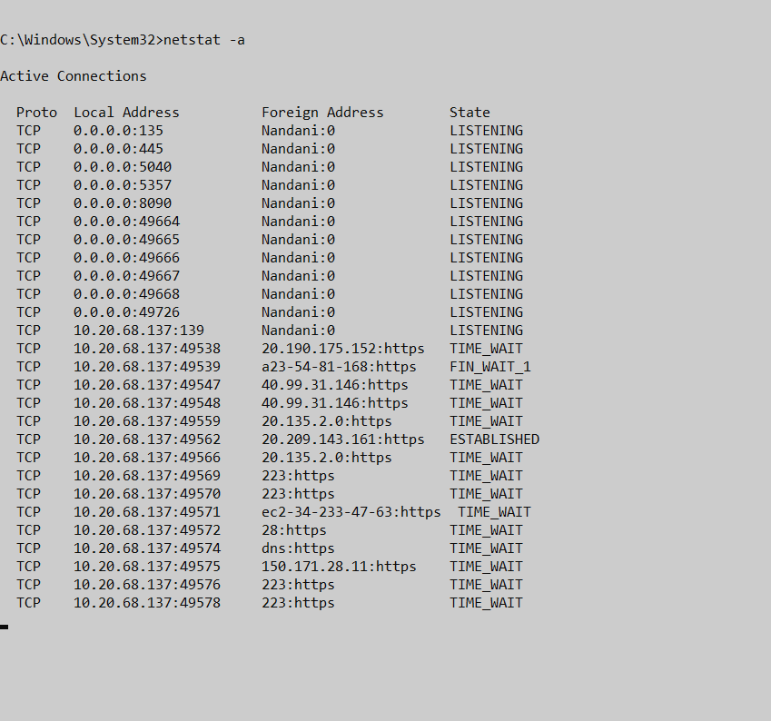Netstat -a:

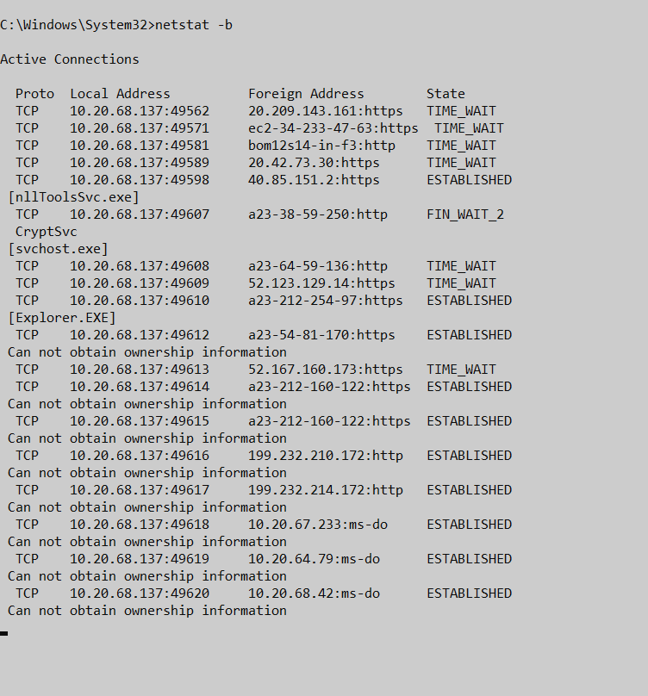Netstat -b:

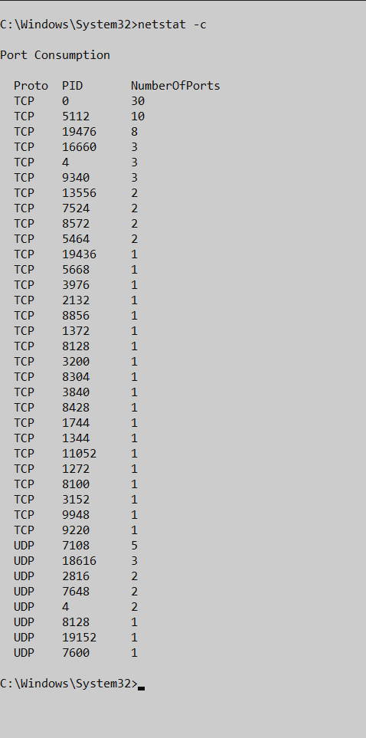netstat -c:

## Nslookup

### Description:

* Checking if a domain is correctly resolving to an Ip.
* Finding mail servers for a domain.
* To see the Ip address of a domain.
* Helpful in networking and website troubleshooting.

|  |  |  |
| --- | --- | --- |
| No. | Option | Description |
| 1 | Host (host google.com) | Any device with an Ip address. |
| 2 | Server (nslookup) | A host that provides a service. |

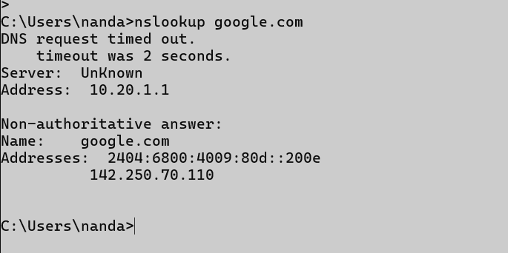Host:

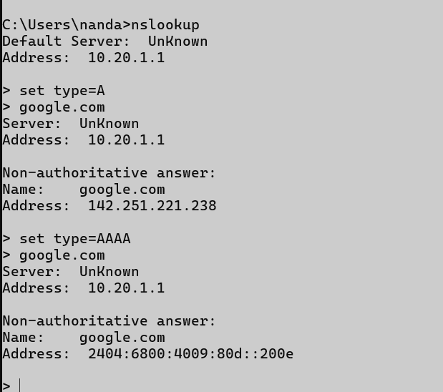Server:

## Hostname

### Description:

* See the current name of the machine.
* This hostname helps in identifying a device on a network.

|  |  |  |
| --- | --- | --- |
| No. | Option | Description |
| 1 | hostname | Show current hostname. |

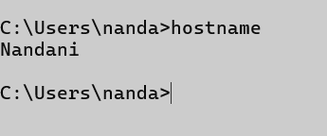Hostname:

## Pathping

### Description:

* The pathping command helps you find where your network connection is slow or losing data.
* Here’s how you can use it in a very simple way.

|  |  |  |
| --- | --- | --- |
| No. | Option | Description |
| 1 | /? (pathping) | Shows detailed info like connection name and status. |
| 2 | /h <hops> | Sets max number of hops |
| 3 | /q <quires> | Number of pings per hop |
| 4 | /w <timeout> | Wait time per reply in ms |
| 5 | /4 or /6 | Force IPv4 or IPv6 usage |

Pathping /h 2 google.com:

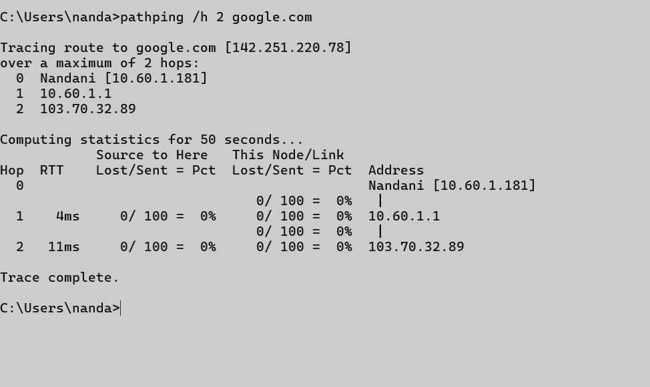

Pathping /q 2 google.com:

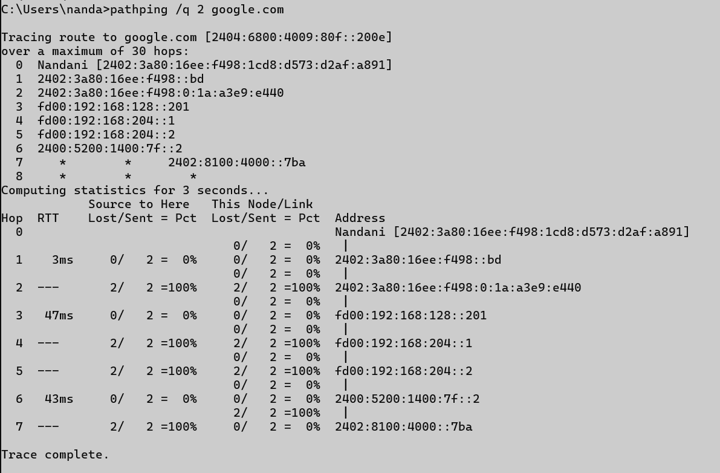

Pathping /w 2000 google.com:

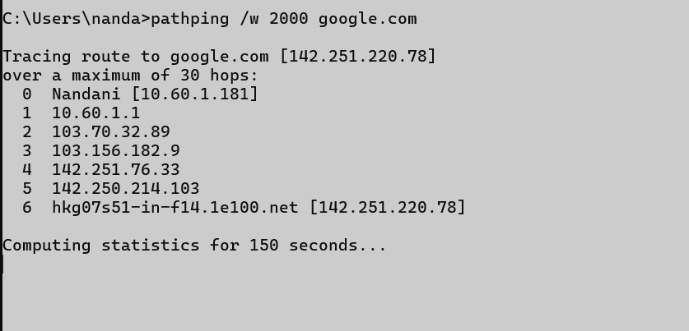

Pathping /4 google.com:

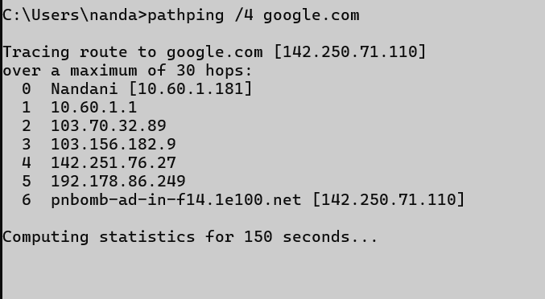

## Arp

### Description:

* ARP stands for Address Resolution Protocol.
* It is used to find the MAC address of a device from its Ip address in a local network.

|  |  |  |
| --- | --- | --- |
| No. | Option | Description |
| 1 | Arp/? | Shows help for all systeminfo commands. |
| 2 | Arp -a | Shows the ARP table (IP to MAC address mapping) |

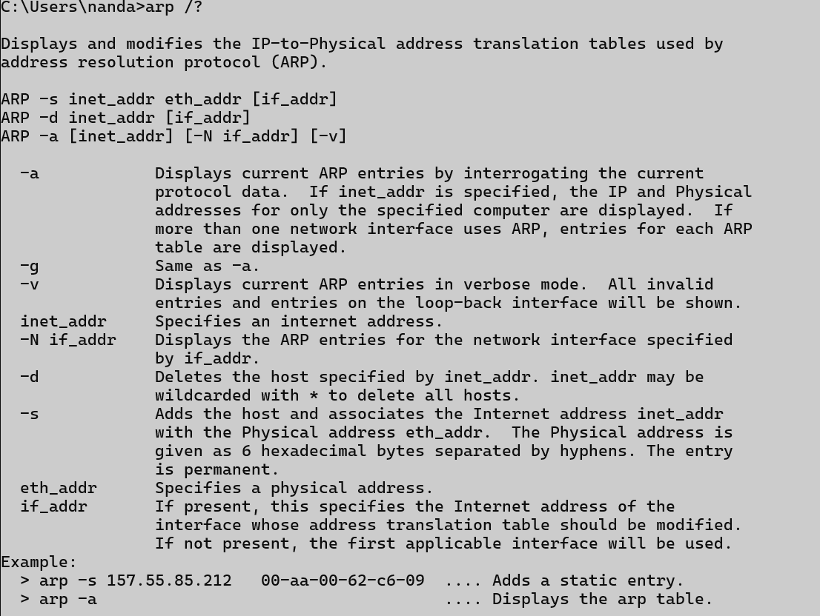Arp/?

Arp -a